# Project Outline (Mouse movement detection)

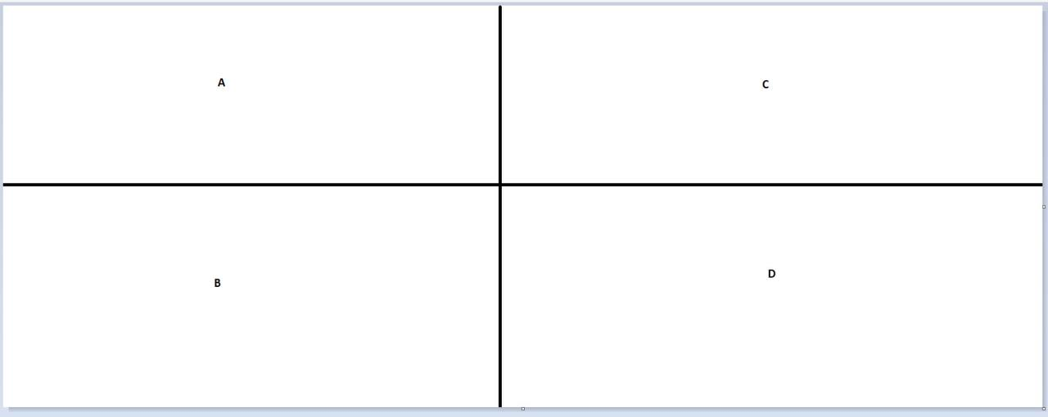

The screen will be split into four quadrants with the boundary lines. Anytime the mouse passes the boundary line, the program will be tasked to add one to the previous sum and then printed.